**NIT3222**

**Virtualisation in Computing**

**Assignment 1**

**Report Title:**

**Design and Implementation of a Highly Available HR Department Service Using Windows Server 2022 Failover Clustering**

Name: Mehakpreet Kaur

Student ID: s8074762

Campus: Melbourne (Footscray Park)

Company Short Name: SA (SmartAuto)

Network: 168.40.62.0/24

**Table of Contents**

Contents

1. Introduction 2

2. Requirement Description and Analysis 3

3. System Design 5

# 1. Introduction

**1.1 Purpose of the Report**

This report outlines the design and implementation of a high availability (HA) infrastructure for the HR department of SmartAuto (SA). The goal is to ensure continuous access to HR services even during hardware or system failures. It details the setup of a Windows Server 2022 environment using Active Directory Domain Services (AD DS), iSCSI storage, and Failover Clustering to achieve reliability and fault tolerance.

**1.2 Scope of the Solution**

The project deploys a resilient server infrastructure for the HR department within the Melbourne campus network (168.40.62.0/24).  
It includes:

* saKaurDC: Domain Controller for authentication and DNS
* saKaurSTO: Storage Server with iSCSI Target for shared storage
* saKaurVH1: Cluster node 1 providing redundancy and failover cluster host
* saKaurVH2: Cluster node 2; Failover cluster host

This configuration ensures continuous service delivery and data protection during maintenance or server failure.

**1.3 Overview of High Availability Concepts**

High Availability (HA) reduces downtime and improves service reliability.  
Key technologies include:

* Failover Clustering: Automatic service continuity if a node fails
* Live Migration: Seamless VM transfer between cluster nodes
* iSCSI Shared Storage: Centralized disks accessible to all cluster nodes
* Active Directory (AD DS): Centralized authentication and DNS services

Combined, these technologies create a robust, self-recovering HR system that maintains business operations with minimal interruption.

# 2. Requirement Description and Analysis

This section analyzes the **business**, **technical**, and **system** requirements needed to design and implement a **high availability solution**. It also defines the **hardware**, **software**, **naming**, and **network addressing** conventions used throughout the project.

**2.1 Business Requirements**

The HR department at **SmartAuto (SA)** requires continuous access to employee records, payroll, and internal systems. The infrastructure must minimize downtime, ensure data protection, and support automatic recovery during failures or maintenance.

**2.2 Technical Requirements**

To meet the above business needs, the technical solution must include the following components:

|  |  |  |
| --- | --- | --- |
| **Component** | **Function** | **Purpose** |
| **saKaurDC** | Domain Controller (AD DS + DNS) | Centralized authentication and DNS services |
| **saKaurSTO** | iSCSI Storage Server | Provides shared storage for cluster nodes |
| **saKaurVH1 / saKaurVH2** | Cluster Nodes | Host application VM and provide redundancy |
| **Failover Cluster** | 2-node cluster | Manages live migration, failover, and automatic recovery. |

**2.3 Hardware and Software Requirements**

|  |  |  |  |  |
| --- | --- | --- | --- | --- |
| **Server** | **CPU** | **RAM** | **Disk** | **Role** |
| saKaurDC | 2 vCPU | 4 GB | 60 GB | Domain Controller |
| saKaurSTO | 2 vCPU | 4 GB | 80 GB + iSCSI Disks | Shared Storage |
| saKaurVH1 | 4 vCPU | 8 GB | 80 GB | Cluster Node 1 |
| saKaurVH2 | 4 vCPU | 8 GB | 80 GB | Cluster Node 2 |

All VMs run Windows Server 2022 Datacenter Edition on Hyper-V with a shared external switch named SA-External-Switch.

**2.4 Network Design and IP Address Plan**

**Domain Name: sakaur.local**

**Cluster Name: saKaurCluster**

**Network: 168.40.62.0/24 (Gateway 168.40.62.1)**

|  |  |  |  |
| --- | --- | --- | --- |
| **VM Name** | **Role** | **IP Address** | **Remarks** |
| saKaurDC | Domain Controller | 168.40.62.10 | Primary domain controller |
| saKaurSTO | Storage Server | 168.40.62.20 | iSCSI target for shared disks |
| saKaurVH1 | Cluster Node 1 | 168.40.62.31 | Cluster host node 1 |
| saKaurVH2 | Cluster Node 2 | 168.40.62.32 | Cluster host node 2 |

**2.5 Naming Conventions**

|  |  |  |
| --- | --- | --- |
| **Element** | **Format** | **Example (for Mehakpreet Kaur)** |
| **Domain Name** | <company><lastname>.local | sakaur.local |
| **Server Names** | <company><lastname><role> | saKaurDC, saKaurVH1 |
| **Cluster Name** | <company><lastname>Cluster | saKaurCluster |
| **Virtual Switch** | <company>-External-Switch | SA-External-Switch |

**2.6 Summary of Key Assumptions**

* All VMs are hosted in a Hyper-V environment.
* Static IP addressing is used for network consistency.
* Shared storage is configured using iSCSI Target on saKaurSTO.
* Failover clustering is configured between saKaurVH1 and saKaurVH2.

# 3. System Design

The SmartAuto (SA) HR system is designed for high availability using Windows Server 2022 Datacenter Edition.  
It consists of five virtual servers running in Hyper-V, all connected through the 168.40.62.0/24 network and joined under the sakaur.local domain.

|  |  |
| --- | --- |
| **Server** | **Function** |
| **saKaurDC** | Domain Controller providing AD DS and DNS |
| **saKaurSTO** | Storage Server hosting iSCSI targets |
| **saKaurVH1 / saKaurVH2** | Failover Cluster Nodes hosting the application |

This setup ensures continuous availability and automatic recovery if one node fails.

**3.2 Logical Network Diagram**

The SmartAuto (SA) HR system is designed for high availability using Windows Server 2022 Datacenter Edition.  
It consists of five virtual servers running in Hyper-V, all connected through the 168.40.62.0/24 network and joined under the sakaur.local domain.

**Figure 1:** Logical Network Diagram of SmartAuto HR Department High Availability Solution

**3.3 Physical Infrastructure Diagram**

**Figure 2:** Physical Infrastructure Layout of Virtual Machines on Hyper-V Host

**Description:**  
The physical design illustrates the virtual machines running on your Hyper-V host machine. Each VM is connected through an **external virtual switch (SA-External-Switch)**, enabling communication within the subnet and access to shared storage.

All systems are hosted locally under:

C:\VMs\

├── saKaurDC

├── saKaurSTO

├── saKaurVH1

├── saKaurVH2

**3.4 Resource Summary**

|  |  |  |  |  |
| --- | --- | --- | --- | --- |
| **VM** | **CPU** | **RAM** | **Disk (GB)** | **Role** |
| saKaurDC | 2 vCPU | 4 GB | 60 | AD DS + DNS |
| saKaurSTO | 2 vCPU | 4 GB | 80 + iSCSI | Storage Server |
| saKaurVH1 | 4 vCPU | 8 GB | 80 | Cluster Node 1 |
| saKaurVH2 | 4 vCPU | 8 GB | 80 | Cluster Node 2 |

**3.5 High Availability Logic**

* Failover Clustering: Provides redundancy between VH1 and VH2.
* Live Migration: Allows seamless transfer of the saKaurAPP VM between nodes.
* iSCSI Shared Storage: Ensures both nodes access the same virtual disks for data consistency.

This design delivers a fault-tolerant HR environment with minimal downtime and easy maintenance.

# 4.Implementation

#SS1: Creation of Internal Virtual Switches (SA-Internal-Cluster and SA-Internal-iSCSI) using PowerShell in Hyper-V for SmartAuto High Availability Network. These switches enable communication between cluster nodes and iSCSI storage for the HR department’s highly available infrastructure.

SS2: Hyper-V Manager showing four virtual machines — saKaurDC, saKaurSTO, saKaurVH1, and saKaurVH2 — created and running on host saKaurHOST for the SmartAuto High Availability (HA) infrastructure.

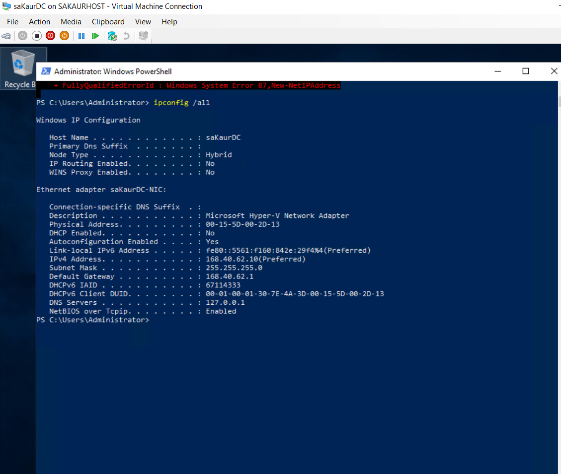

#SS3: “Static IP and DNS Configuration for saKaurDC

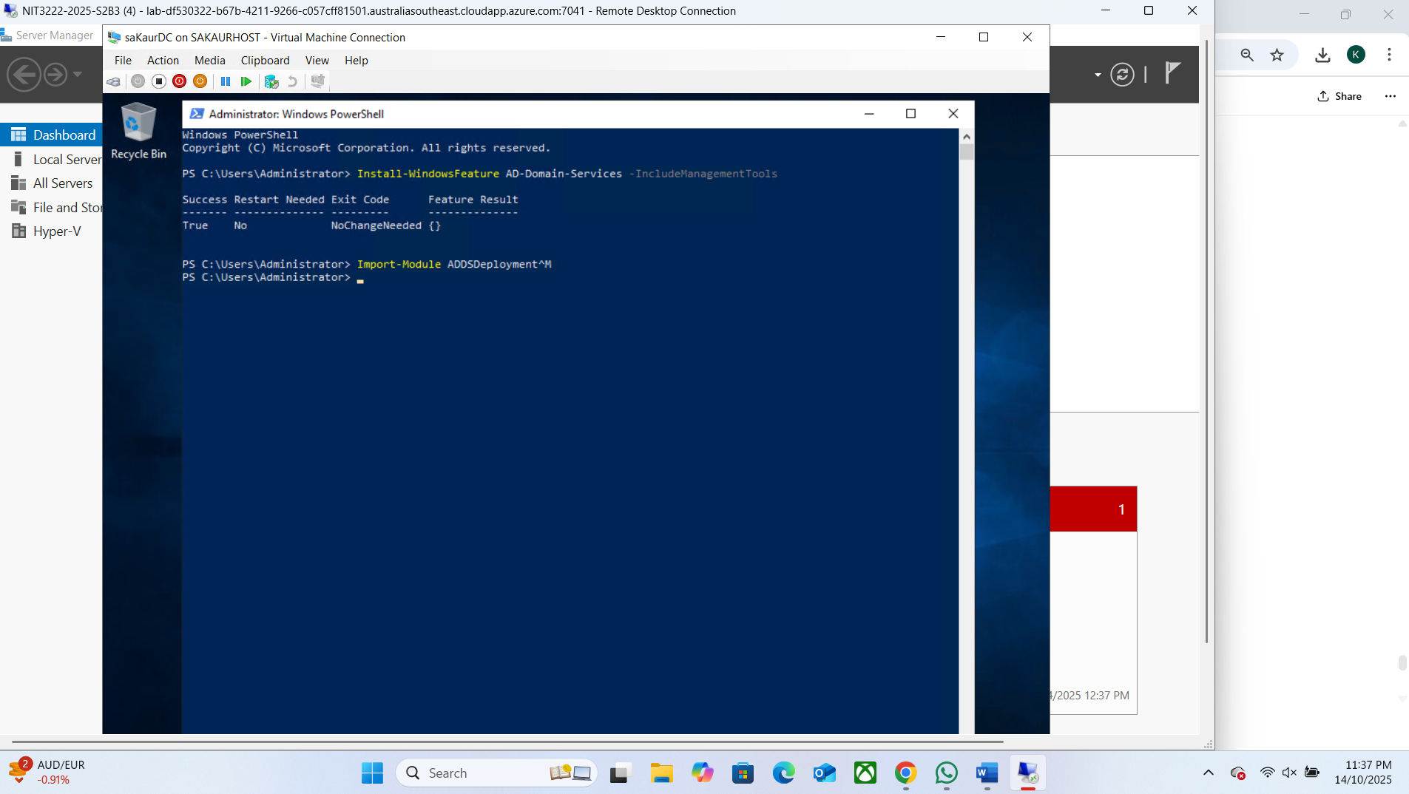

#SS4: PowerShell output showing successful AD DS installation.

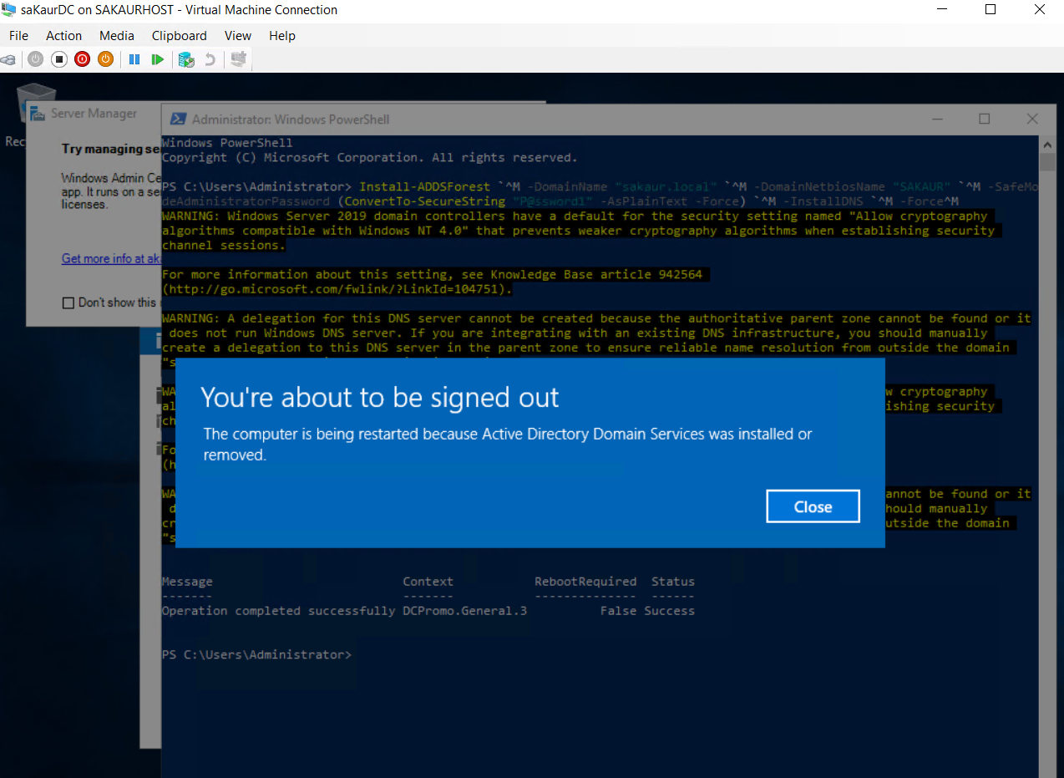

#SS5: Installation of Domain

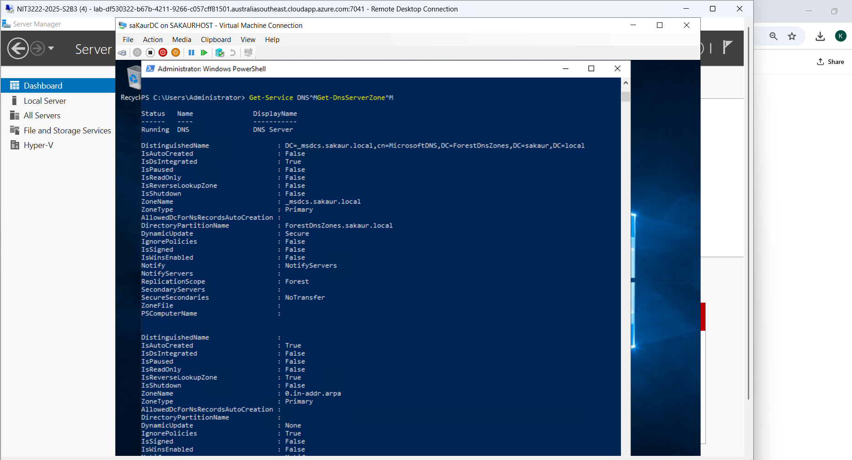

#SS6: Verification of DNS zone sakaur.local on saKaurDC.

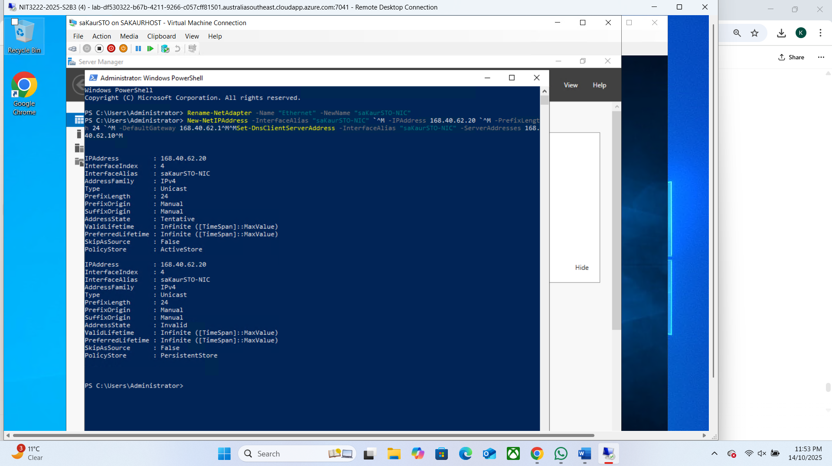

#SS7: Static IP and DNS configuration for saKaurSTO.

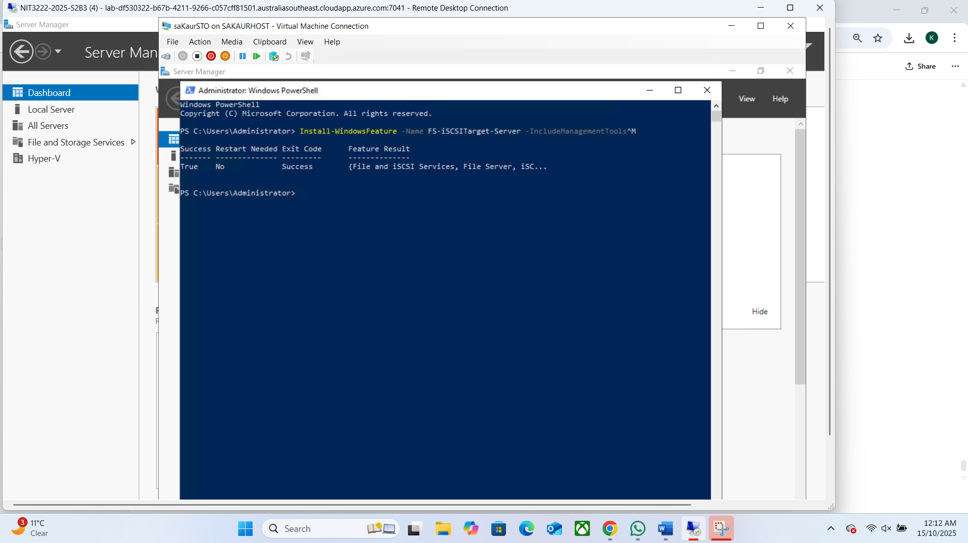

#SS8: iSCSI Target Server role installed successfully on saKaurSTO

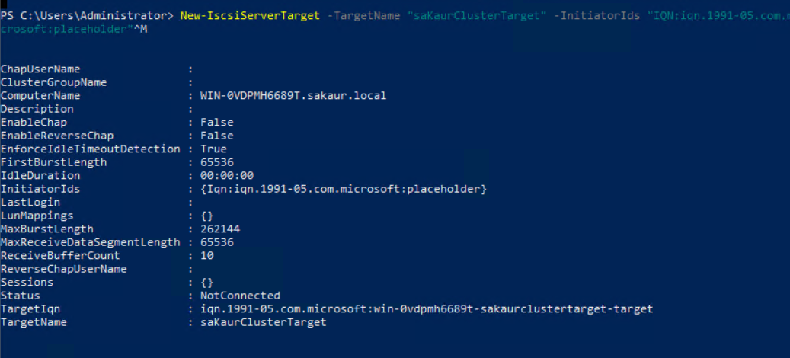

#SS9: Created iSCSI Target ‘saKaurClusterTarget’ successfully on saKaurSTO.

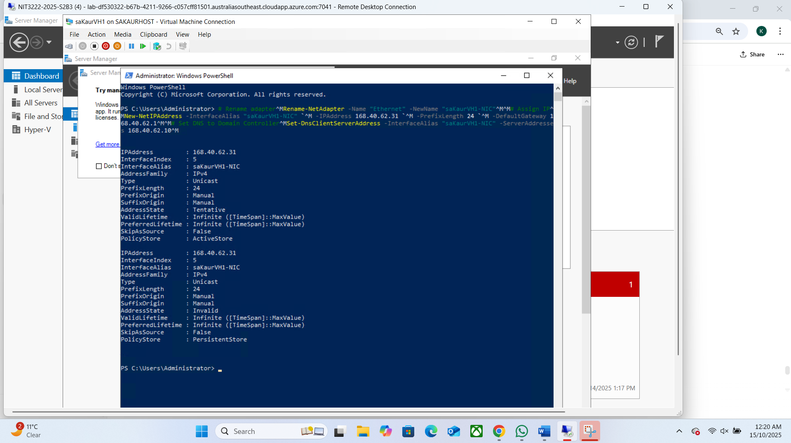

#SS10: Static IP 168.40.62.31 configured for saKaurVH1.

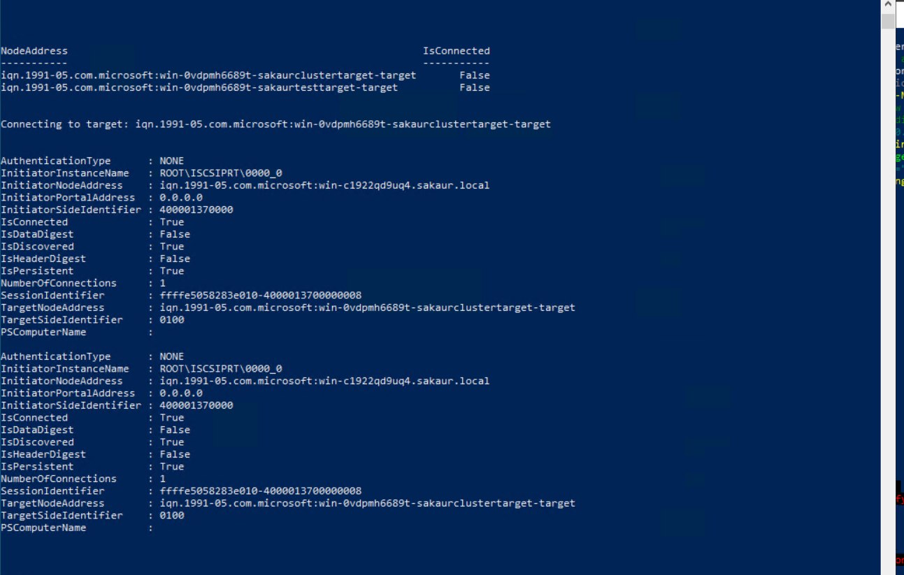

#SS11: Successful iSCSI Target Connection on saKaurVH1 and saKaurVH2

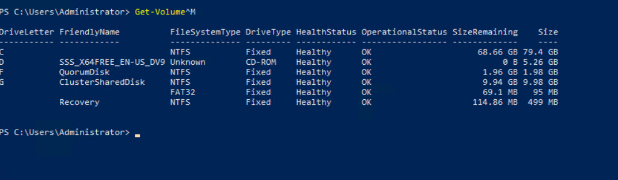

#SS12: SCSI Disks Initialized and Mounted on saKaurVH1

#SS13: Successful Creation of Cluster

#SS14: Adding and Verifying Shared iSCSI Disks in saKaurCluster

#SS 15: Cluster Groups and Node Ownership Status